
Katz Group Canada Limited
5965 Coopers Avenue
Mississauga, Ontario
L4Z 1R9, Canada

September 3, 2003

Dear Mr. Ravi Srinivasan, JDA Software Canada Ltd.

Re: Request for Proposal, Retail Supply Chain Management Systems

Attached, please find the Request for Proposal (RFP) for a Retail Supply Chain Management software suite for Katz Group Canada Ltd. This request has a number of sections for you to complete, and instructions for proposal submission.
Please respond to all sections and attach all pertinent documentation.

Response to this RFP is requested by email and hard copy. The emailed response must be received by 5:00pm, Wednesday, September 24, 2003 EST. Hard copies are to be received by Friday, September 26, 2003.

A self-assessment is to be performed using the attached file (Katz Requirements.xls) and the instructions contained therein.

To confirm your intent to respond to this RFP, please sign the Statement of Confidentiality in Appendix C and fax a copy to myself at 905-502-5618, by 5:00 PM on Friday, September 5, 2003.

Katz Group Canada will hold an information session for all vendors participating. This session will be held from 9:00 AM to 12:00 PM on Friday, September 12, 2003 at the:

Toronto Airport Hilton
Ontario Room
5875 Airport Road
Mississauga, Ontario

From Pearson International Airport: Complimentary shuttle

Coming from East: Take Highway 401 Westbound to Highway 409 Westbound, exit on Airport Rd. and turn Left. The Hilton Toronto Airport Hotel is on your Left through the second set of lights.

Coming from West: Take Highway 401 Eastbound to Highway 427 north, exit on Dixon Rd. and turn Left. The Hilton Toronto Airport Hotel is on your Right after the Esso gas station.

Please contact me for answers to any questions. Thank you.

Sincerely,

Mr. Alan Pinington
IBM Business Consulting Services
Selection Project Consultant
alp@ca.ibm.com
Phone: 905-316-3322
Fax: 905-502-5618



Request for Proposal
Retail Supply Chain Management Systems
September 3rd, 2003

CONFIDENTIALITY NOTICE
The following document is intended only for use in the Request for Proposal process. This report includes information which is privileged and confidential. This report must be handled as a confidential document within your organization. No part of this document may be distributed, reproduced, quoted from, or discussed outside your organization without written approval from Katz Group Canada Limited.

Table of Contents
1.0 Overview 5
1.1 Purpose of the RFP 5
1.2 About Katz Group Canada Ltd. 5
1.3 Strategic Objective 6
1.4 Why Retail Supply Chain Management Systems? 6
1.5 Project Scope 6
1.6 Key Business Differentiators 7
1.7 Organization Overview 8
1.8 Key Data 8
1.9 Systems Considerations 9
1.10 IBM’s Role in the Selection Process 9
2.0 Response Instructions 10
2.1 Inquiries 10
2.2 Method of Submission 11
2.3 Selection Process Schedule 12
2.4 Selection Criteria 12
2.5 Confidentiality 13
2.6 Acceptance of Responses 13
2.7 Preparation Cost 13
2.8 Attachments & Appendices Summary 13
3.0 Vendor Information 16
3.1 General Vendor Details 16
3.2 Similar Industry References 22
3.3 Product Information 22
3.4 Implementation Considerations 34
3.5 Product Support 40
4.0 Product Technology 44
4.1 Technical Environment 44
4.2 Integration and Interfaces 51
4.3 Product Limitations 53
4.4 Management Tools 53
5.0 Product and Service Costs 54
5.1 Agreements 54
5.2 Product Costs 55
5.3 Options 60
6.0 Functional Requirements 60
6.1 Retail Supply Chain Management Requirements 60
6.2 Additional Systems Capabilities 61
Appendices 62
Appendix A: Katz Store Map and Head Office Locations 62
Appendix B: Present Application Systems Overview 64
Appendix C: Statement of Confidentiality 65
Appendix D: Key Business Capabilities & Probable Business Releases 66
Appendix D: To-Be Process Maps Based on Leading Practices 67

1.0 Overview

1.1 Purpose of the RFP

The purpose of this Request for Proposal (RFP) is to solicit vendor submissions for evaluation of retail supply chain management systems. This RFP is being submitted to five software vendors.

1.2 About Katz Group Canada Ltd.

Katz Group Canada Limited (herein referred to as Katz) is Canada’s leading integrated retail pharmacy network. With over 1,500 corporate, franchise and independent pharmacies, Katz has more pharmacies across Canada than any other retail pharmacy network.

Many of Canada’s most trusted and recognized pharmacy banners are members of the Katz network. Banners include:
- Pharmx Rexall Drug Stores Ltd.
- Pharma Plus Drugmarts Ltd.
- Medicine Shoppe Canada Inc.
- Guardian—Drug Trading Company Limited
- I.D.A.—Drug Trading Company Limited
- Herbies for Drug and Food/Payless
- MEDITrust—Canada's only national mail order pharmacy

Katz’s mission, through its PharmAssist™ brand and program, is to maintain and foster excellence in pharmacy care and services within its network.

In addition to pharmacy banners, Katz holdings include Drug Trading Company Limited, Canada’s oldest and largest pharmacy retail cooperative, D.C. Labs Limited (product packaging/manufacturing) and ProPharm Limited (pharmacy systems software/hardware development and services).

Katz Group Canada Ltd. is a division of Katz Group Inc. Based in Edmonton, Katz Group Inc. is a privately held company owned by majority shareholder Mr. Daryl Katz. In addition to Canadian holdings, Katz Group Inc. owns and operates Drug Emporium and Snyders Drug Stores in the United States.

1.3 Strategic Objective

Katz’s overall business strategy is:

Our corporate stores will be the pharmacy of choice for the time-constrained female shopper seeking everyday health solutions, basics and seasonal merchandise for herself, her home and her family. We will be conveniently located, community stores that will provide current and innovative merchandise in an efficient, friendly and appealing shopping environment.

1.4 Why Retail Supply Chain Management Systems?

Process improvements enabled by new merchandising and supply chain systems are required to enable Katz to achieve its business strategy and respond to anticipated consumer demand.

Katz needs to deliver superior customer service and added value through the effective flow of physical goods, visibility of associated information and management of the entire business. Systems and processes must enable efficient merchandise and inventory planning within the extended supply chain. Performance measurement, transactional and decision support capabilities must assist in revenue enhancement and cost containment efforts.

Katz’s supply chain initiative has mandated the selection of a retail supply chain management system for Katz. The selection phase follows a strategic supply chain assessment completed in July 2003. The recommendations from the study specified a comprehensive road map that requires implementation of a corporate retail supply chain management system.

1.5 Project Scope

The scope of this system selection project is focused predominantly on the business requirements of Katz’s head office and the corporate stores but also considers those of the independent store network. The intent is to find one cost-effective applications architecture (i.e. one solution or one set of solutions) that will meet the requirements of the complete Katz retail organization.

Vendors are asked to submit proposals on the best implementation strategy for their respective solutions given the organizational model currently deployed in Canada. Again, while this initiative is focused on Katz’s Canadian business, Katz’s expectations are that the selected system will be eventually rolled out to Katz’s US operations.

1.6 Key Business Differentiators

Key functional requirements were identified through cross-functional workshops. Katz’s key business differentiators include:

Multi-banner organization
- Katz operates multiple banners, multiple store sizes (200 to 15,000 sq feet) with regional and location-specific variances in the merchandise mix. Katz must be able to cluster stores based on demand or by user defined criteria. Katz needs the ability to plan merchandise at a store department or category based on unique demand. The objective is to optimize store sales through store specific assortment and planograms.

Entrepreneurial spirit
- Katz operates as an entrepreneurial organization which results in a need to support rapid change. This requires a system that can be rapidly reconfigured with a minimal time and effort.

Usage of distribution channel
- The acquisition of the majority of Katz product is outsourced to multiple distributors. Katz has a requirement to increase control and visibility over its supply chain processes requiring systems with the ability to collaborate with external systems (i.e. forecasting, product planning, replenishment orders, invoices, visibility of external inventory, allocation, etc.).

Proprietary POS systems in stores
- Katz operates over 300 corporate stores which have proprietary point of sale (Auto-Star) and dispensary systems (Nexxsys). Katz requires an interface to synchronize data (item, price, sales, inventory, replenishment orders, etc.) between both systems.

Variety of product identifier tags
- Product identification varies by commodity type and includes item #’s, UPC #’s, PLU #’s, DIN and Pack size. The system must be able to support these identification types. This is due to the fact that Katz sells drug, grocery and sundry items.

Multiple units of measure
- Planning and execution modules will need to operate using multiple units of measures. Katz sells and inventories items by units, weight and volume.

1.7 Organization Overview

- Company Locations Affected by New Systems (see Appendix A)

- Multi-currency Requirements
Katz buys, sells and reports in multiple currencies, primarily Canadian and U.S. dollars, although Yen and the Euro may be required in the future.

- Multi-language Requirements
Katz requires system screens and reports to be available in multiple languages, with the ability for the user to set the language of preference. English and French are the official languages of Canada and must be supported.

- Customer Channels
- Stores (Retail Drug, grocery)
- Mail Order
- Web based

- Regulatory Requirements
- Health Canada
- Provincial Health Ministries
- Provincial Colleges of Pharmacists
- Personal Information Protection and Electronic Documents Act (Bill C6)

1.8 Key Data

Consolidated Sales | CD$4.2 Billion
Number of corporate stores | 310
Number of independent stores | 1264
Number of franchise stores | 70
Average lines per store replenishment order | 8
Number of vendors | 3,150
Rx | 150
CPG | 3,000
Monthly purchase orders | 270,000
Number of active items | 119,000
Rx | 9,000
CPG | 110,000

These figures represent current performance. Future growth may result in increases of between 20% and 50%.

1.9 Systems Considerations

In the full implementation, there will be approximately 400 corporate users (head office), with about 200 concurrent sessions. The potential for store connections needs to be taken into consideration.

1.10 IBM’s Role in the Selection Process

While IBM is an active participant in the development of this RFP and overall facilitation of the selection process, the final selection decision will be made solely by the Katz selection team.

2.0 Response Instructions

2.1 Inquiries

Efforts have been made to ensure that this RFP document provides adequate information for you to base your responses on. However, should you have any questions or require further clarification, please direct inquiries to:

Mr. Alan Pinington
IBM Business Consulting Services
Selection Project Consultant
alp@ca.ibm.com
Phone: 905-316-3322
Fax: 905-502-5618

Please do not contact Katz directly regarding this RFP. IBM is the sole contact per Katz’s request, to provide each vendor with an efficient and consistent level of service. IBM will ensure any and all questions regarding the selection process and RFP are answered expeditiously. IBM will also facilitate responses for any additional Katz information that may not be contained herein. Although IBM is the main contact point, Katz will be provided all copies of all correspondence.

To confirm your intent to respond to this RFP, please sign the Statement of Confidentiality in Appendix C and fax a copy to Alan Pinington at 905-502-5618. This is to be done by 5:00 PM on Friday, September 5, 2003.

On Friday, September 12, 2003, Katz will hold an information session for all vendors participating in this process. This session will be held from 9:00 AM to 12:00 PM at the:

Toronto Airport Hilton
Ontario Room
5875 Airport Road
Mississauga, Ontario

From Pearson International Airport: Complimentary shuttle

Coming from East: Take Highway 401 Westbound to Highway 409 Westbound, exit on Airport Rd. and turn Left. The Hilton Toronto Airport Hotel is on your Left through the second set of lights.

Coming from West: Take Highway 401 Eastbound to Highway 427 north, exit on Dixon Rd. and turn Left. The Hilton Toronto Airport Hotel is on your Right after the Esso gas station.

In preparation for this session, please submit any questions you may have by email to Alan Pinington by September 10, 2003. We will consolidate the questions and provide responses at this information session. Also, please include a list of people (and their positions) from your company who will be attending the information session. The VP of Information Technology and the Director of Distribution Services from Katz will be available for discussion.

2.2 Method of Submission

Please submit your formal proposals to be delivered no later than 5:00 PM EST, Wednesday, September 24, 2003.

To facilitate your response, the RFP document has been made available in Microsoft Word and Excel format. All respondents should use the format included herein to respond to this document (i.e. where a text box has been provided, please complete or paste your response directly into the text box)

Electronic responses are required and should be sent to:

Mr. Alan Pinington
alp@ca.ibm.com

Please send all electronic submissions with an urgent delivery tag. Late responses will not be considered.

Due to potential email size restrictions (i.e. 10MB) responses in CD-Rom format will also be acceptable.

Six printed hard copies of your proposal and supporting documents should also be submitted to the following address, couriered by 5:00 PM, Wednesday, September 24, 2003:

Mr. Alan Pinington, IBM Business Consulting Services
Selection Project Consultant
Katz Group Canada Limited
5965 Coopers Avenue
Mississauga, Ontario
L4Z 1R9
Canada

Your response to this RFP shall become the property of Katz and will not be returned. Costing/pricing data that is provided by vendors will remain strictly confidential.

2.3 Selection Process Schedule

The selection process includes the following steps:
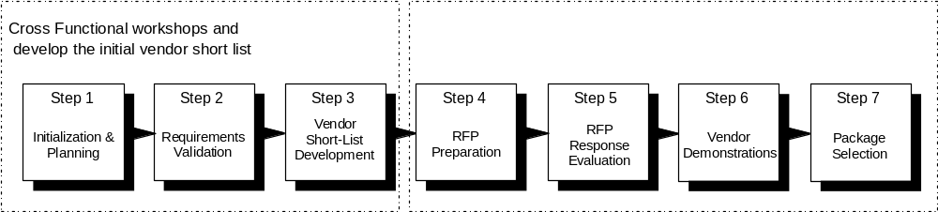

The two vendors deemed by the Katz selection team and process to best meet the requirements of this RFP will be notified on Oct 1, 2003. These two vendors will receive detailed demonstration scripts upon which they will be asked to conduct solution demonstrations between Oct 15 and Oct 23.

The tentative timetable for the proposal, evaluation and selection process is as follows:

Activity | Date (All times are EST)
RFP issued to pre-selected vendors | Sept. 3, 2003
Deadline for submitting signed Statement of Confidentiality agreement | 5:00 PM Sept. 5, 2003
Information session | 9:00 AM Sept. 12, 2003
Proposals due from vendors | 5:00 PM Sept. 24, 2003
Selection of two final vendors | Oct. 1, 2003
Demonstration scripts sent to short listed vendors | Oct. 2, 2003
First vendor demonstration | Oct.15-17, 2003
Second vendor demonstration | Oct. 21-23, 2003
Vendor customer site visits | Oct. 27-31, 2003
Notification of preferred vendor | Nov. 28, 2003

2.4 Selection Criteria

Our selection will be based primarily on the following criteria:

- Software Functionality
- Software Technology
- Total Costs
- Vendor Support (Implementation & ongoing)
- Vendor Vision / Viability
- Experience with Retail Drug industry

2.5 Confidentiality

The information in this document is strictly confidential to Katz. Vendors are requested to exercise extreme care in the distribution of this document. Dissemination of the strictly confidential information must be controlled, and distribution must be limited to the vendor's immediate organization, its agents and only those subcontractors who are needed to assist in responding to this RFP.

All responses from Katz, IBM or their representatives to vendors' questions, whether oral or written, must also be considered strictly confidential.

2.6 Acceptance of Responses

Katz reserves the right to accept or reject any or all responses, to take exception to, delete or modify these RFP guidelines, or to waive any formalities. This document is an invitation for response.

The vendor acknowledges that Katz will be relying on responses submitted by vendor pursuant to this RFP and that such responses are material to any negotiations which may result from this RFP or any contract which may be awarded pursuant to this RFP. Vendor covenants that all such responses will be complete and accurate in all material respects.

2.7 Preparation Cost

Katz is not liable for any costs incurred by any vendor prior to signing a formal contract by all parties concerned. The vendor will assume all costs incurred in providing responses to the RFP and for providing any additional information required for Katz to facilitate the evaluation process.

2.8 Attachments & Appendices Summary
An explanation of the contents of each attachment and appendix follows.

Appendix A: List of Company Locations

The list of company locations is listed to provide the vendor with a sense of the size and complexity of Katz. As evidenced within the list, Katz operates within a Canada wide retail and distribution network.

Appendix B: Present Applications Overview

The applications currently in use at Katz are identified to give a sense of which business activities are supported by application systems at Katz today.

Appendix C: Statement of Confidentiality

The confidentiality agreement to be signed and faxed back to Alan Pinington is included.

Appendix D: Key Business Processes

The high-level business processes related to merchandising and supply chain management are provided to give the vendor a sense of what Katz deems as business critical functionality.

Attachment: Functional Requirements

This attachment is an Excel Spreadsheet (Katz Requirements.xls) that contains Katz’s functional requirements. The functional requirements section of this document contains instructions on how to work with this document. Vendors are to perform a self assessment utilizing this spreadsheet.

3.0 Vendor Information

3.1 General Vendor Details

Please complete the following for each vendor contributing to your proposed solution (cut and paste the sections and change the headings for multiple vendors).

3.1.1 Proposal Contact Information

Descriptor | Response
Name | Ravi Srinivasan
Address | Suite 200  14505 Bannister Rd SE  Calgary, AB T2X 3J3
Phone Number | 403-212-3076
Fax Number | 403-252-9605
Email Address | ravi.srinivasan@jda.com

3.1.2 Head Office Information

Descriptor | Response
Address | 14400 N. 87th Street  Scottsdale, AZ 85260-3649
Phone Number | 480-308-3000
Fax Number | 480-308-3001

3.1.3 Vendor Employee Profile

Descriptor | Number of Employees
Total Global | 1250
Total Canada | 53
Total United States | 853
R&D | 421
Development | 415
Product Support | 173
Marketing | 19
Sales | 68
Tech. Pre Sales | 47
Administration | 107

3.1.4 Company History

Please provide a brief history of your company. What is your company’s number of years of established business presence in Canada and in total? Please list the countries that your company has an office in and is capable of providing technical support.

COMPANY HISTORY:
In the late 1970’s, James D. Armstrong was a wanted man. His computer programming skills were so marketable that six of the seven companies with whom he had interviewed extended job offers. Rather than have the companies compete in a bidding war, Jim named his own salary … and hired himself. Since computer skills were in such high demand, Jim knew the time was right to launch his own company. In 1978, he formed JDA Software Services in Calgary, Alberta, which grew to be one of Canada’s largest IBM Midrange software providers.

The Canadian business was sold in 1985 and Jim, with a partner, formed the U.S.-based JDA Software, Inc. in Cleveland, Ohio. The company’s vision was to deliver quality, packaged software and consulting services to address the retail industry’s information management and transaction processing needs. After signing a substantial contract with a Phoenix-based automotive retailer in 1987, the company and its eight employees relocated to Arizona.

After ten years of successful operations as a private firm, JDA became a public corporation on March 15, 1996 and began trading on the NASDAQ as JDAS. Another highlight of 1996: JDA re-purchased the original Canadian “JDA” company and re-established our presence in Canada.

Over the years, JDA’s commitment to the industry’s evolving requirements has secured our market leading position. Our global sales and delivery infrastructure includes offices in countries throughout the world, which enables the Company to serve more than 4,600 clients in over 60 nations.

JDA’s passion for profits has provided the Company with the financial freedom to strategically expand the JDA Portfolio offering. JDA began in 1998 to look externally for complementary, high-value solutions. Our aggressive activity includes eight acquisitions in five years:
- August 2003: JDA acquired Engage, Inc., an innovative provider of enterprise advertising, marketing and promotion (AMP) software solutions.
- May 2003: JDA acquired the intellectual property assets of Vista Software Solutions, an innovative provider of collaborative commerce solutions for the retail and consumer goods industry.
- April 2002: J•Commerce, a privately held developer of Java™ point-of-sale solutions.
- September 2001: E3 Corporation, the global leader of inventory optimization systems, which added 550 customers in 20 countries.
- June 2001: NeoVista products, which serve as the foundation of JDA’s Advanced Optimization data mining applications.
- February 2001: Zapotec Software, Inc.’ software products for managing advertising and promotion expenditures between retailers and their manufacturers.
- April 2000: Intactix division, the market-leading provider of space management solutions for retailers, suppliers, and manufacturers, which added more than 3,000 clients worldwide.
- June 1998: Arthur Retail division, the market leader in advanced planning and allocation software, which added approximately 240 clients.

Please see Attachment A: JDA Company History Timeline for a detailed listing of key historical events.

OFFICES:
JDA has over 29 offices worldwide, within the following countries.

- Canada
- United States
- Singapore
- Japan
- Malaysia
- Australia
- Mexico
- Chile
- Brazil
- United Kingdom
- Germany
- Sweden
- France
- Spain
- Italy
- Denmark
- Norway
- Finland
- Dubai

3.1.5 Client Install Base

Please provide the number of live installations in Canada and in total. Also provide the number of live installations in the Retail Drug industry in Canada and in total.

The following is a breakdown of active clients by product:

Product | Total | CDN | Drug Industry | CDN Drug Industry
PMM | 61 | 6 | 2 | 0
Portals | 5 | 1 | 0 | 0
VistaRetail | 20 | 0 | 0 | 0
Space & Floor Planning on IKB | 891 | 70 | N/A | N/A
EIA | 92 | 5 | N/A | N/A
CCI | 4 | 0 | 0 | 0
ASR | 31 | 3 | 2 | 2
SPI | 4 | 0 | 0 | 0
IDEAS | 91 | 13 | 1 | 1
Revenue Mgmt (VIM, MEM) | 32 | 3 | 1 | 1
ELF | 0 | 0 | 0 | 0
Merchandise Planning | 196 | 10 | 2 | 0

3.1.6 Company Financials

Please provide audited company financials for the past three years and a published Credit or Dun & Bradstreet rating for your company. Include any other financial information to indicate financial health of your company.

JDA Software Group, Inc. is a publicly owned company and is traded on the NASDAQ Stock Exchange with the symbol JDAS. Please see the following attachments:
- Attachment B: JDA 2001 Form 10K
- Attachment C: JDA 2002 Form 10K
- Attachment D: JDA Q2 2003 Earnings Release

JDA is a subscriber to Dun and Bradstreet Monitoring Scope and are under contract to use the service for internal use only. JDA is not legally authorized to issue reports externally. However, our Duns Number is 94-260-3325 and our Primary Name for consolidated reports is JDA Software Group, Inc.

3.1.7 Litigation

Please describe any pending or past litigation that you have been involved with during the last 5 years.

JDA does not disclose information concerning claims or litigation unless the information is "material" according to the Securities and Exchange Commission ("SEC") guidelines for public company filings in the United States . Any legal action that we believe is material will be disclosed in our SEC filings from time to time. Our past and most recent SEC filings can be reviewed online at http://www.sec.gov/edgar/searchedgar/companysearch.html.

3.1.8 Differentiation

Please explain what differentiates you from your competitors specifically in the Retail Drug industry.

JDA has the following key strengths that differentiate us from other companies in our market and put us in the position to best serve Katz Group. These unique strengths are:

1. Industry leading process innovation – JDA is uniquely positioned to connect the supply chain of Katz, Mckesson, and their suppliers because this integration will be between JDA E3 application suite. Unlike our competitors we have already established store to warehouse to supplier optimization in production environments. JDA is also best suited to have product synchronization services enabled from ECCNet to McKesson and Katz with our Vista application suite.

2. Time to Market
- Our Portfolio of solutions are architected so that point solutions can be quickly installed to achieve faster ROI. The JDA advantage of integration is such that over time as point solutions are installed the various components will work together cohesively. This approach will provide Katz the unique opportunity to change direction and relieve unforeseen business pressures over the next 2 – 3 years as the entire business solution is being deployed.

3. Single Point of Responsibility – Katz will have one senior JDA associate who will be responsible for all aspects of the Katz relationship. This will include sales, implementation and on-going support. Our observation is that this process results in project objectives being delivered with a level of consistency and over time leads to a strong and proactive relationship.

4. Experience – JDA has over 24 years in partnering with retailers, wholesalers and manufacturers. Our client base is over 4,800. Our clients operate in many business segments including apparel, automotive, cards & gifts, catalogue, mail-order, E-retail, house wares & crafts, specialty non-apparel, jewellery, theme retail, toys & hobbies, mass merchandise/club, grocery, drug and cosmetics.

5. Significant investment

in our products – In the last 5 years JDA has invested $339 million into developing and acquiring solutions for our clients. In 2003, we plan on investing in excess of $40 million in product development and enhancements.

6. Satisfied Client Base – Approximately 66% of our software license revenues in 2002 came from existing customers buying additional products. This indicates how our existing clients view JDA and have confidence to reinvest in our solutions.

7. Financial Stability & Strength – JDA is a financially strong organization. In our 24-year history we have always had positive financial results. Our annual revenues exceed $200 million. We have experienced a 58.5% revenue growth rate over the last five years (1998 through 2002). All of this was accomplished while we maintained our corporate financial strategy of not acquiring long-term debt. JDA maintains a positive cash flow throughout the year and maintains significant cash on hand balance. We will be here tomorrow and the day after to serve you and to further improve your IT investment.

8. Total
Solution Offering - Our Portfolio of solutions includes best-of-breed software as well as consulting services, support and education that will lead to your success at every level of your enterprise. JDA Consultants bring you the knowledge and the power of software developed based on our clients’ and the market’s needs. From assessing your technical architecture to applying best practices, JDA will work with your staff to execute a well-organized implementation. Any project of this magnitude will carry risks and be potentially disruptive, but this is mitigated by our Customer Solutions Group’s experience. JDA training, and in particular the training provided by JDA’s Business Management Institute (BMI), has become a de facto standard in training in supply and retail industries.

9. Focus – Our software solution focus is entirely on the retail demand and supply chains. JDA’s consultants and trainers work with retailers, manufacturers and wholesalers every day. Many of our team members in support, product management, development and design have joined JDA after years of real world experience as buyers, planners, inventory control specialists, distribution managers, and financial specialists from a wide variety of retailers.

10. Multi-Channel Clients - Our clients operate in many channels, these include brick & mortar, catalog and e-commerce. Some of our clients have multiple channels of operation.

11. Best Forecasting and Planning Solutions - JDA’s Portfolio Advanced Planning Solutions by Arthur™ has been designed to be the most flexible and reliable planning application in the marketplace. Our forecasting and planning solutions have the most client installations. Since JDA’s acquisition of Arthur in 1998, we have invested substantially in advancing the product to maintain its market leadership.

3.2 Similar Industry References

Please provide three (3) relevant examples of previous installations in the retail industry (i.e., similar size, similar process, similar suite of modules, etc.) preferably in the Retail Drug sector.

Please note: These organizations will not be contacted at this time without prior consent from the vendor. However, short listed vendors will be required to coordinate site visits with one or more customers whom have successfully implemented your solution.

3.2.1 Customer Reference #1

Descriptor | Response
Organization Name | CVS Corporation
Head Office Address | 1 CVS Drive  Woonsocket, RI 02895
Brief Description of Organization | CVS/pharmacy is made up of 110,000 associates in over 4,100 stores, 9 distribution centers, regional offices, PharmaCare headquarters, and the Store Support Center in Woonsocket, Rhode Island. Their annual sales exceed 24 billion.
How is the customer similar to Katz | Drug and Cosmetics business segment.
Number of Users Supported | CVS is a tier 1 client with multiple users in multiple departments.
Version of Software Currently Running | See Module below.
Modules Implemented | - Portfolio Advanced Replenishment Solutions by E3®  - Portfolio Space Management Solutions by Intactix™  - Marketplace Replenish™ (collaborative)
Countries Supported / Global | USA
Implementation Duration | Varied based on product, but can be discussed with Katz Group in further detail in the future.
Other integrated / interfaced applications | Varied based on product, but can be discussed with Katz Group in further detail in the future.
Go Live Date | Varied based on product, but can be discussed with Katz Group in further detail in the future.
Hardware and OS Platform Being Used | Varied based on product, but can be discussed with Katz Group in further detail in the future.
Database Platform Being Used | Varied based on product, but can be discussed with Katz Group in further detail in the future.
Approx Total Cost of Implementation | Due to confidentiality agreements, JDA does not release this information.

3.2.2 Customer Reference #2

Descriptor | Response
Organization Name | H. E. Butt Grocery Company
Head Office Address | 646 South Main Ave.  San Antonio, TX 78204
Brief Description of Organization | H.E. Butt operates over 300 grocery stores including health and beauty aids and pharmacy departments. Their annual sales are estimated to exceed $9.9 billion and they have in excess of 60,000 associates.
How is the customer similar to Katz | H.E. Butt’s stores have health and beauty aids and pharmacy departments.
Number of Users Supported | H.E. Butt is a tier 1 client with multiple users in multiple departments.
Version of Software Currently Running | See modules below.
Modules Implemented | - Portfolio Advanced Planning Solutions by Arthur™ (entire suite)  - Portfolio Merchandise Management™  - Seasonal Profiling by Intellect™  - Channel Clustering by Intellect™  - Portfolio Space Management Solutions by Intactix™  - Engage (AMP Solution)
Countries Supported / Global | USA and Mexico
Implementation Duration | Varied based on product, but can be discussed with Katz Group in further detail in the future.
Other integrated / interfaced applications | Varied based on product, but can be discussed with Katz Group in further detail in the future.
Go Live Date | Varied based on product, but can be discussed with Katz Group in further detail in the future.
Hardware and OS Platform Being Used | Varied based on product, but can be discussed with Katz Group in further detail in the future.
Database Platform Being Used | Varied based on product, but can be discussed with Katz Group in further detail in the future.
Approx Total Cost of Implementation | Due to confidentiality agreements, JDA does not release this information.

3.2.3 Customer Reference #3

Descriptor | Response
Organization Name | Farmatodo, S.A.
Head Office Address | Urbanizacion Industria La. Trinidad  Calla del Arenal  Edificio Placio  Pico 3  Caracas, Venezuela
Brief Description of Organization | Retail Drug store operator.
How is the customer similar to Katz | Farmatodo operates in the Retail Drug store business segment.
Number of Users Supported | Varied based on product, but can be discussed with Katz Group in further detail in the future.
Version of Software Currently Running | See modules below.
Modules Implemented | - Portfolio Merchandise Management™  - Portfolio Advanced Replenishment Solutions by E3®  - Portfolio Space Management Solutions by Intactix™  - Win/DSS®
Countries Supported / Global | Venezuela
Implementation Duration | Varied based on product, but can be discussed with Katz Group in further detail in the future.
Other integrated / interfaced applications | Varied based on product, but can be discussed with Katz Group in further detail in the future.
Go Live Date | Varied based on product, but can be discussed with Katz Group in further detail in the future.
Hardware and OS Platform Being Used | Varied based on product, but can be discussed with Katz Group in further detail in the future.
Database Platform Being Used | Varied based on product, but can be discussed with Katz Group in further detail in the future.
Approx Total Cost of Implementation | Due to confidentiality agreements, JDA does not release this information.

3.3 Product Information

3.3.1 Product Version Information
Please provide the following details for your proposed product. If a combination of products is proposed, please provide details for each product.

Descriptor | Response
Product Name | Portfolio Merchandise Management (PMM)
Version | 2003.5.0
Current Version # | 2003.5.0
Date Released | Q1 2003
Next Release Date | Q1 2004 (You may go live with this version)
Programming Language | Oracle PL/SQL, Uniface
Operating Platform(s) supported | IBM AIX, HP HP/UX, SUN Solaris, NT/2000
Database Management System(s) supported | Oracle 8i
Other tools required to run the application (e.g. developers’ toolkit, query tools, administrator tools, runtime licenses) | Uniface Run-Time License (provided by JDA)  Pro*C Pre-Compiler  C Compiler
Next Release Date
Service Pack # on Current Version

Descriptor | Response
Product Name | Merchandise Planning by Arthur/Arthur Knowledge Base
Version | 2003.5.0
Current Version # | 2003.5.0
Date Released | Q1 2003
Next Release Date | Q1 2004 (You will probably go live with this version)
Programming Language | Microsoft Visual C++ on Client, PL/SQL- Database
Operating Platform(s) supported | Oracle UNIX, AIX, NT on database and Windows 98, 2000 on Client
Database Management System(s) supported
Other tools required to run the application (e.g. developers’ toolkit, query tools, administrator tools, runtime licenses) | Arthur Architect
Next Release Date | Q1 2004
Service Pack # on Current Version

Descriptor | Response
Product Name | Performance Analysis by IDEAS
Version | 2003.5.0
Current Version # | 2003.5.0
Date Released | Q1 2003
Next Release Date | Q1 2004 (You will probably go live with this version)
Programming Language | PowerBuilder, C++
Operating Platform(s) supported | UNIX,AIX, NT
Database Management System(s) supported | Oracle SQL Server
Other tools required to run the application (e.g. developers’ toolkit, query tools, administrator tools, runtime licenses) | Silvon
Next Release Date | Q1 2004
Service Pack # on Current Version

Descriptor | Response
Product Name | Advanced Store Replenishment by E3
Version | 2003.6.0
Current Version # | 2003.6.0
Date Released | Q3 2003
Next Release Date | Q1 2004 (You will probably go live with this version. It is the .NET UNIX version)
Programming Language | The host software is primarily RPF and CL. The client is primarily C++.
Operating Platform(s) supported | JDA supports all publicly supported AS/400 operating systems. This includes V4R1 and later.
Database Management System(s) supported | The database is inherent AS/400 DB2. Development is underway for Oracle.
Other tools required to run the application (e.g. developers’ toolkit, query tools, administrator tools, runtime licenses) | TCP/IP is used to link the client and host. The host needs an RPG compiler, Application Development Toolset, and Query. RSF by BugBusters is used to provide remote support.
Next Release Date | Q1 2004
Service Pack # on Current Version | 6.0

Descriptor | Response
Product Name | Space Management By Intactix
Version | 2004.1
Current Version # | 2003.6
Date Released | Q2 2003
Next Release Date | Q1 2004 (You will probably go live with this version)
Programming Language | 32-bit MFC C++ Application  32-bit ODBC enabled  OpenGL enabled for 3D
Operating Platform(s) supported | Designed for Windows 2000, WindowsXP after version 2.5.7, NT 4.0 (Service Pack 6), Windows ’98 SE, and Windows 95 prior to version 3.0
Database Management System(s) supported | Designed to access data in any ODBC compliant format. When used with Intactix Knowledge base, it accesses either SQL Server (7 and 2000), and/or Oracle 8i databases.
Other tools required to run the application (e.g. developers’ toolkit, query tools, administrator tools, runtime licenses) | For IKB NB Reporting is through either customized ASP reporting or through Crystal Reports (Version 8.5).
Next Release Date | Q1 2004
Service Pack # on Current Version | For NT 4.0 Service Pack 6 is required.  The Intactix Database is designed to function on Windows NT Workstation SP6a, Windows 2000 SP1, Windows NT Server SP6a, Windows 2000 Server, and Windows XP Professional for both SQL and Oracle databases, as well as Unix on NT, AIX, SUN, or HP machines for Oracle databases.  The Intactix Application Server (containing the Data Server and Presentation Server components), Intactix Image Server, and Intactix Publishing Server are all designed to function on Windows 2000 SP3, Windows 2000 Server SP3, and Windows 2000 Advanced Server SP3 (preferred).

3.3.2 Product Integration

Please describe the integration capability of your solution with external applications. What features of your solution make it a good fit in a multi-application environment?

The primary hub for integration with external solutions comes from the JDA merchandising and transaction engine PMM. PMM is designed to feed information to other JDA systems as required through the use of flat file and XML based files depending on the business process requirements and timeliness of the information required.

The module within PMM that is designed to manage the two-way flow of external information is called System Data Interchange (SDI). The way this module works is it will capture audits of data maintenance activity through Oracle triggers. Based on configuration PMM will determine which external systems need which pieces of information, and at what level of detail. SDI will then process the required information, into a comprehensive set of standard SDI Export tables ready to be picked up and/or delivered to each specific external system. PMM also has a large number of standard SDI Import tables that are can be used for initial data loading or data conversion, as well as for ongoing interfaces to bring data from external systems into PMM. Please note that before any data is inserted into PMM’s base tables, it is fully validated to guarantee the integrity of the PMM database. Invalid data is rejected and on-line screens are provided for viewing and correcting rejects.

When deploying point solutions, like Intactix or E3, these solutions have their own internal capabilities of accepting and sending information back to non-JDA systems and therefore do not require PMM to be live for interfacing data.

3.3.3 Language Support

Please list the languages supported by your software package.

PMM can be configured into any number of languages through its native multi-lingual capabilities. Off the shelf translation are available for English, French, Spanish, and other translations can be done on demand by our Portfolio Localization Services group. In addition, an NLS module is provided to allow our clients to do their own localization as required to support specific language dialects.

3.3.4 Currency Support

Please list the currencies supported by your software package.

PMM can support an unlimited amount of currencies.

3.3.5 Localization

Has your software package been localized to meet Canadian specific requirements? Describe these localizations (i.e. taxes, government regulations).

Our experience has been that the inherent flexibility of PMM has been adequate to support the Canadian marketplace without need for localization. GST, PST, HST, Environmental Levies are all configurable within PMM’s tax setup. We also provide all of the Multi-Lingual and currency conversion requirements of a Canadian Retailer.

3.3.6 Concurrent Users

What is the maximum number of concurrent users by role?

There is no fixed limit within PMM. The number of users is only constrained by the amount of processing capability available to PMM, and potentially, Oracle licensing considerations.

3.3.7 Acquisition Information

If applicable, please describe the components contained in the proposed solution that resulted from an acquisition. Please include the date that the product was integrated into the solution and the method employed.

The following products are including within our proposal and either their original or current version has been acquired through acquisition:
- August 2003: JDA acquired Engage, Inc., an innovative provider of enterprise advertising, marketing and promotion (AMP) software solutions.
- May 2003: JDA acquired the intellectual property assets of Vista Software Solutions, an innovative provider of collaborative commerce solutions for the retail and consumer goods industry. Within this proposal we are including the acquired VistaRetail solution.
- September 2001: E3 Corporation, the global leader of inventory optimization systems, which added 550 customers in 20 countries. Within this proposal we are including the acquired and enhanced E3 Advanced Store Replenishment solution.
- June 2001: NeoVista products, which serve as the foundation of JDA’s Advanced Optimization data mining applications. Within this proposal we are including the acquired and enhanced Seasonal Profiling by Intellect and Channel Clustering by Intellect solutions.
- February 2001: Zapotec Software, Inc.’ software products for managing advertising and promotion expenditures between retailers and their manufacturers. Within this proposal we are including the acquired and enhanced Vendor Incentive Management and Marketing Expense Management solutions.
- April 2000: Intactix division, the market-leading provider of space management solutions for retailers, suppliers, and manufacturers, which added more than 3,000 clients worldwide. Within this proposal we are including the acquired and enhanced Space Planning by Intactix, Floor Planning by Intactix and Intactix Knowledge Base solutions.
- June 1998: Arthur Retail division, the market leader in advanced planning and allocation software, which added approximately 240 clients. Within this proposal we are including the acquired and enhanced Arthur Merchandise Planning RAPID solution.

3.3.8 Research & Development

Explain your organization’s commitment to investing in R&D to continuously improve the product and stay on top of developments in the marketplace. How much is spent on Research and Development annually in advancing the solution/application/system?

In the last three years JDA has invested over $200 million in building and buying new products and since 1998, JDA has invested $339 million into developing and acquiring solutions for our clients. In 2002 JDA Software invested in excess of $40 million in product development and enhancements. In 2003 we will be investing in excess of $40 million.

In addition to this JDA funded R & D we also engage in additional customer funded R & D for major product enhancements. In this case the client will pay between 100% - 25% of the development cost for new functionality.

3.3.9 Product Documentation

List the product documentation that is provided.

In addition to the documentation provided with the software delivery, JDA will provide one hardcopy of the detailed, course training guides to each BMI course participant. Additional training manuals can be purchased in electronic, Adobe-Acrobat format (CD) or in hardcopy.

3.3.10 Industry Focus

Please specify commitments or focus your company has placed / undertaken on or in Retail Drug industry.

JDA maintains a very good representation of the Retail Drug industry within our 4,800 client base. Specific examples of pharmacy vertical implementations include Advance Forecasting and Replenishment implementations at CVS/Pharmacy, Rite Aid, Eckerd Drug, Shoppers Drug Mart, Value Drug Mart, Happy Harry’s as well as a number of grocery chains. The Boots Company uses our host merchandising system, PMM, while H. E. Butt Grocery Company, Meijer, Inc. are JDA’s strategic partners in the ongoing enhancement of our merchandise systems. This strategic partnership will ensure further development of our systems to support the Grocery/Drug Store Retail industry.

Within our Retail Drug Industry client base, JDA has taken a leadership position in Supply Chain efficiency as evidenced by our presence at such clients as Eckerd, CVS. Our specialty is in providing CPFR enablement for point to point connections. Our clients have also won the coveted VICS CPFR implementation award for 2003. (The ROI from these implementations will be made available to you.)

Within Canada we have market dominance with our E3 Forecasting and Replenishment application running at Shoppers Drug Mart, McKesson, Jean Coutu, and Value Drug.

JDA is also in the midst of working with ECCNet to work thru some industry initiatives for product synchronization and image and dimension information for the Retail Drug Industry.

What vertical markets does your company participate in and what is the percentage of revenue generated from each?

The major vertical segments we generated revenue from are Drug, DIY, Mass merchant, discount retail, specialty retail. Although JDA does not report revenues by business segment, we do know that JDA generates 80% of it’s revenues from retailers and 20% from manufactures. We believe we have the broadest representation of retail business segments in the retail demand and supply chains. JDA’s customer base includes more than 4,800 of the world’s leading retail, manufacturing, and wholesale organizations. This results in JDA having the largest retail customer installed base among our direct competitors, with more than 1,200 retail customers in over 60 countries. Our customers include many of the world’s leading retail, manufacturing and wholesale organizations including Anheuser-Busch Companies, Carrefour, Ahold, Colgate-Palmolive, H. E. Butt Grocery Company, Meijer, Inc., Shaw’s Supermarkets, and Wal-Mart in addition to the Retail Drug clients listed in 3.3.10.

The retail business segments JDA participates in include: apparel, automotive, consumer electronics & appliances, drug & cosmetics, grocery, hardware, garden & building materials, house wares & crafts, jewelry, music, books, videos & software, convenience stores, discount, department & general merchandise, furniture & home furnishings, optical & camera, and sporting goods.

3.4 Implementation Considerations

It is Katz’s intention to begin the implementation process for the retail supply chain system selected as part of this process commencing December 2003.

3.4.1 Implementation Methodology

Please provide a detailed description of your preferred implementation methodology. Take our functional requirements (Katz requirements.xls) and planned business releases (Appendix D) into consideration. Break it down by module and include time estimates to complete each business release.
To successfully deliver a solid return on investment from Portfolio implementations, the JDA Customer Solutions Group, our experienced strategic planning, business process optimization and implementation services team, utilizes our proven project methodology Optimum Pathways.
Attachment E: Customer Solutions Group details the services provided in a standard implementation and provides guidelines for value-added services, such as Strategic Planning, which many of our customers employ to clarify their goals. At a high-level, JDA provides the following core services for every implementation:
Initial Planning & Training
- Project Planning
- Product Overview Training
- Kick Off Meeting
- Initial Software Load
- Development of Initial Plan
Discovery & Design
- Performance Baseline
- Review of Current Processes
- Process Workshops (Functional & Technical)
- Systems Review
- System & Process Documentation
Construction & Quality Control
- Technical Team Training
- Detailed Configuration
- Development of Test Scripts and Test Plan
- System Integration Testing Support
- User Acceptance Testing Support
Implementation
- Pre-Implementation Assessment & Planning
- End User Training
- Data Conversion Verification
- Post Implementation Support

Along with the services detailed above, Katz Group will be supported by the JDA’s Project Management team. This team focus’ their energy on getting the job done on time, within budget, while meeting project objectives. This includes integrating all aspects of the project, managing project scope, timelines, budgets, communications, risk and human resources while still following the ‘best practices’ as defined by the Project Management Institute. Where it makes sense a separate project manager will be assigned to each product being implemented, but where one project manager can successfully manage multi-product implementations JDA would assign one manager accordingly. Along with the Project Manager JDA will also assign an overall Engagement Manager whose goal will be to ensure consistency and focus throughout the multi-product implementations.

To achieve the implementation objectives set out by Katz in Appendix D JDA would propose the following phased implementation:

Phase 1: (15 months)
- Portfolio Merchandise Management
- Store Portal
- VistaRetail
- Space Planning by Intactix and Intactix Knowledge Base
- Efficient Item Assortment
- Channel Clustering by Intellect

Phase 2: (5 months)
- Advanced Store Replenishment by E3
- Seasonal Profiling by Intellect
- Vendor Incentive Management

Phase 3: (4 months)
- IDEAS
- Marketing Expense Management
- Event Lift Forecasting
- Arthur Merchandise Planning RAPID
- Floor Planning by Intactix

3.4.2 Software Upgrade Methodology

Please specify your software upgrade methodology for patches and version releases.

Version Releases:
Our R&D team is continuously enhancing our product functionality by adding in new features, and incorporating new technologies, such as versions of our third-party development tools and operating system components. The results of these efforts are new releases of our products that we provide to our clients so that they can achieve a greater return on their software investment.

Before a new release is deemed ready for ‘General Availability’, each module will undergo extensive testing by JDA’s Quality Assurance Group. JDA is also committed to cross-product integration so we also test each release’s integration with other JDA products to confirm that they are providing a true enterprise solution.

Once a release has passed our rigorous testing, the new releases is made ready for ‘General Availability. Typically JDA makes available one major and one minor release per year. All of these updates need to be released simultaneously for all products so that we apply integration updates keeping our software synchronized.

Patch Releases:
Service Packs include product fixes and are available as needed by the product. These may be combined into one cumulative package for those clients who wish to reduce the installation frequency.

JDA supports the current version of the product and one prior release. If and when we can assist with earlier releases we will do so.

Release Documentation:
The following documentation is provided with New Releases and Service Packs:

- Release Letter - This document explains the functional and technical changes included in the release.
- Program Change Log - Notes describing modifications are provided and can be viewed online or listed on a report.
- Installation Guidelines - This document describes the steps necessary to install the new release.

3.4.3 Implementation Timeframe

Based on your experience, what would be a realistic timeframe for implementation, by module or major system and by total duration? The estimate can be provided in terms of a range (e.g., 2-3 months).

Based on our experience and the phasing approach being taken we would estimate the following durations for each phase:

Phase 1 – (15 months)
- Portfolio Merchandise Management
- Store Portals
- VistaRetail
- Space Planning on Intactix Knowledge Base
- Efficient Item Assortment
- Channel Clustering

Phase 2: (5 months)
- Advanced Store Replenishment by E3
- Seasonal Profiling by Intellect
- Vendor Incentive Management

Phase 3: (4 months)
- IDEAS
- Marketing Expense Management
- Event Lift Forecasting
- Arthur Merchandise Planning RAPID
- Floor Planning by Intactix

3.4.4 Implementation Resources

Based on your experience in similar implementations, what types of customer resources would be required to ensure that the implementation was successful?

The list of resources below is a high level estimate. After further discovery and analysis, JDA will be able to provide Katz Group with a much more detailed resource listing per product and phase.

Phase | Resource Type | Qty | Level of Effort
Overall | Client Executive  Executive responsible for budget of the project. Oversees Project Manager, direct liaison with Executive Steering Committee. This individual can be the CIO or SVP with more than one department responsibility. | 1 | 5-10%
Overall | Client Change Management  Change Management includes the identification, tracking, definition of an action plan, and execution of the actions to support process and organization change associated with the JDA Portfolio implementation. | 1 | 100%
Each Phase | Client Project Manager  Manages day-to-day activities of project, direct liaison with JDA Engagement Manager/Project Director. This individual has business experience and the confidence of the executive team. | 1 per product implementation | 100%
Each Phase | Client Functional Users  Merchandising, Planning, Allocation, Reporting and Analytics with knowledge of current business practices, ability to make procedural decisions, capability to learn PMM to support implementation.  (eg. Buyers, Merchandise Planners, Forecasters, Space Planners) | 1-4 depending on the product being implemented | 35 -100% depending on phase
Each Phase | Client Technical Users  This knowledge will vary from staff members with knowledge of current platform, operating system, network and technical knowledge of current applications; programming knowledge, architecture knowledge, interface knowledge, down to technical users that can learn new solution functionally and technically to support the project.  (eg. DBA, Technical Infrastructure Manager, System Analysts, Lead Programmer Analysts, Integration Developers, System Architects) | 1-4 depending on the amount of integration work | 35-100% depending on phase
Each Phase | Client Trainers  Key users responsible for learning new solutions so that they can comfortably train end users. | 1-3 depending number of users to train | 100% during training phase
Each Phase | Client Testers  Key users responsible for learning new functionality for the business area they represent. Often participates in activities such as user acceptance testing, and end user training. | 1-4 depending on product being implemented | 35-100% depending on phase

3.4.5 Training

Based on your experience in similar implementations, what type of training investment is required by Katz to successfully implement your product? Please identify the type of training that is available and recommended.

JDA’s training organization, Business Management Institute (BMI) offers industry-leading education that trains your employees on their machines with their data. We can train Katz Group associates at a JDA location or at your office location. Typically, initial training is face-to-face with additional follow up and/or optional advanced classes offered in face-to-face or web based environments

BMI provides training for our client’s project staff, technical and system users. At BMI, our knowledgeable instructors can meet Katz Group’s unique requirements by:
- Offering instruction at our corporate office in Scottsdale, one of our regional offices or at your local office.
- Teaching your students using high-quality courseware.
- Customizing the courses along with the accompanying documentation to meet your specific requirements. We can also condense the training materials with information specific to your users' daily responsibilities.
- Helping you evaluate your training or re-training needs to accommodate staff turnover, software upgrades or improved productivity using the system.

Due to the mix of products proposed to Katz Group JDA is proposing a training package of 500-days. This will allow Katz Group to receive the most value for their training budget while still providing their associates with world-class training. The cost of a 500-day BMI package is $480 per student day ($240,000 total), which is a 20% discount off of the regular $600 per student day ($300,000 total).

The way our training packages work is each package contains a fixed number of training days, and each training day is ONE class day, for ONE student. For example, if you want to send 4 students to the 3 day Merchandise Planning Administration by Arthur course, 12 training days would be used (4 x 3). The more training days you purchase in your package, the greater the discount you get. Package days can be used by anyone within your organization, and have a one or two year expiration date, depending on the package. In addition, package days can be used for campus classes or off-campus classes.

For a detailed listing on all BMI offered courses that Katz Group can choose from, please refer to the ‘Education’ section of www.jda.com.
JDA is also engaged in an existing new e-learning initiative. For further details please refer to Attachment F – e-Learning from BMI.

3.5 Product Support

3.5.1 Support Services

Please describe the support services you provide. Within the description please reference 24* 365 capabilities and the average / min / max wait times for each type of support service (phone, web, etc.).

JDA’s standard support hours are 8:00 am until 5:00 pm each business day (client head-office time, Monday thru Friday), but based on client requirements JDA does offer additional hours of support. For further details on all of our support packages please see Attachment G: JDA Client Support Programs for information on our standard support and optional support services.

Below is an overview of JDA’s Service Level support and response times:

Service Levels and Response Time

Severity 0 – Business standstill with no work around - issues that prevent a client from proceeding with a major mission-critical process that is an absolute necessity in the live daily operations of the business.

Target Service Levels for Severity 0
- Target response time – 1 business hour based on customer entitlement
- Target Status Update time – every 4 hours

Severity 1 – Business Critical Issues with no feasible work-around – issues that cause a serious disruption to the business but do not necessarily impede the live daily running of the business.

Target Service Levels for Severity 1
- Target response time – 4 business hours based on customer entitlement
- Target Status Update time – the next day and weekly for program failure or data integrity
- Target Status Update time - monthly for design or performance

Severity 2 – Non-business critical coding, data integrity, design or performance issue with a complex or time-consuming workaround.

Target Service Levels for Severity 2
- Target response time – 4 business hours based on customer entitlement
- Target Status Update time – Within 1 week and then monthly after that

Severity 3 – Simple coding issue with an easy and/or convenient workaround.

Target Service Levels for Severity 3
- Target response time – 4 support hours based on customer entitlement
- Target Status Update time – Clients can call or check Heat Web

Severity 9 – System enhancement request.

NOTE: Any major Design and Performance Issues should be caught prior to using the functionality in a live environment.

3.5.2 Past Version Support

Please describe your support policy for older versions of your software. The description should reference on-going technical support, application patches and service packs.

To ensure that our maintenance paying client base is receiving the benefit of our Research and Development department, JDA provides service packs that include product fixes and are available as needed by the product. These may be combined into one cumulative package for those clients who wish to reduce the installation frequency.

JDA supports the current version of the product and one prior release. If and when we can assist with earlier releases we will do so.

3.5.3 Support Locations

Please provide a list of support locations.

Location (include hours of operation) | Number of Employees
Scottsdale, Arizona  Standard support covers from 8:00 AM until 5:00 PM, local client time, Monday through Friday, with the exceptions of major holidays. Extended hours are available. | 160

3.5.4 Holidays

Please describe your policy on continuing support during local holidays and Canadian holidays.

As an optional support service, JDA will provide pre-scheduled on-request extended coverage on weekends, local and Canadian holidays.

3.5.5 Escalation Procedures

Please describe your support escalation procedures.

Below is an overview of JDA’s escalation process:

Escalation Process
Internal JDA escalation will happen for Severity 0, 1, and 2 issues as follows, within both of these JDA teams:

Client Support Escalation:
- Escalated to Support Manager
- Escalated to Support VP or Director
- Escalated to Sr. VP of Support

Development Escalation:
- Escalated to Application Manager
- Escalated to Development Manager
- Escalated to VP of Development
- Escalated to Sr. VP of Development

If the client wants to escalate within JDA, the following escalation path should be followed:
- Call the JDA Solution Line and ask to speak with a Supervisor
- Escalate to the Manager Client Support Services (CSS) team based on the product
- Escalate to the appropriate CSS Director/VP based on the product
- Escalate to Sr. VP of Portfolio Client Support

3.5.6 User Groups

Please provide a list of locations and contact names for any user groups.

At JDA we are dedicated in providing our customers with life long support be it through JDA consultants or through peer networking. As such JDA has established 17 Special Interest Groups (SIG) within our user community, each revolving around a unique product grouping and each maintaining hundreds of members for each maintenance paying client is automatically considered a SIG member. For example PMM, Retail Ideas, and Win/DSS (our store system solution) each are there own SIG with an elected SIG chairperson from within the user community. Within Attachment H: Special Interest Group Outline, you will find detailed information of how the JDA SIGS are structured as well as how they are expected to operate.

In addition to our Special Interest Groups, JDA holds an annual user conference called FOCUS. The purpose of this 4-day event is to allow JDA clients to gain progressive industry and product knowledge to help them improve their efficiency and effectiveness within their organization and with their trading partners. For example this year’s event will feature industry experts and top retail executives sharing innovative business strategies and practices that are proven to help companies achieve phenomenal success. For further information on FOCUS please visit our webpage at http://www.jda.com/focus/index.asp)

Along with the above JDA also supports their users through the following publications and feedback opportunities:
•Customer Satisfaction Report Card
•Tele-briefings
•Premier Partner
•Customer First Newsletter
•Enterprise Newsletter

For contact names please see Attachment I: JDA Users Group Contact List.

4.0 Product Technology

4.1 Technical Environment

4.1.1 Hardware Architecture

Please provide diagrams and narrative (including products used) that detail the Hardware Architecture that best suits your proposed solution.

Until an in-depth hardware sizing exercise is performed we are unable to respond to this question. Given the time frames for the RFP response we are unable to provide you specific details.

The details that we can provide are included within Attachment J: JDA Hardware Architecture.

4.1.2 Hardware Requirements

Based on the parameters we have provided, please complete the following for each potential hardware platform alternative providing both the minimal and optimal hardware requirements. Take into consideration a transaction volume growth of 15% annually.

Until an in-depth analysis is performed we are unable to respond to this question. Given the time frames for the RFP response we are unable to provide you specific details. General guidelines have been provided to you within Attachment J: JDA Hardware Architecture.

4.1.3 Hardware Vendor and Product

Please indicate which Hardware Vendors and Products you support and what percentage each Hardware Vendor and Product represents of your total installed base.

Hardware Vendor and Product | Percentage
Desktop System
Windows 98 | Small
Windows NT | Large
Windows 2000 | Largest
Application Servers
Windows 2000 (only needed for Store Portals) | 100%
Database Server | Oracle 100%
IBM | 50%

4.1.4 Hardware Performance

For each type of server (application, database, web, reporting etc) when system performance is an issue (slow response), what is the preferred method of resolving this? Is it to scale-out (i.e., add new servers) or to scale-up (i.e., to increase components within existing servers such as processors and memory)? At what point does scaling-up stop becoming effective?

Within JDA’s Customer Solutions Group we a have a highly skilled Performance Team who has the responsibility to enhance performance from the architecture that we have proposed. This team in involved in the initial hardware architecture design and pre go live to ensure that we are going to meet expectations. We will also come back about 60 – 90 after go live to complete some further fine tuning exercises. This team has the ability to assess the client’s environment to determine the root of any performance problem and recommend an approach to resolving the issue. This could involve server/DBMS tuning, application configuration, code changes, hardware upgrades or a combination of these. Our preferred approach is to have our performance team come in and resolve the problem without passing the buck by saying “add more hardware” (assuming an adequate hardware sizing exercise was conducted to ensure the initial hardware was appropriately sized).

4.1.5 Software Architecture

Please provide diagrams and narrative (including tools and products used) that detail the Software Architecture that your proposed solution was designed / built on.

Please refer to Attachment K: JDA Software Architecture and Attachment J: JDA Hardware Architecture for further details and diagrams.

In general due to the nature of the solution suite and different behavioral characteristics required our software architecture for a application suite is built to deliver business process required.

4.1.6 Operating Systems

Please indicate which operating systems and versions you support and what percentage each operating system and version represents of your total installed base. Include all alternatives.

Operating System / Version | Percentage
Client Operating System
Windows 95/98 | Small
Windows NT | Large
Windows 2000 | Largest
Application Servers
Windows 2000 | 100%
Database Server
AIX | 50%
HP/UX | 20%
Solaris | 20%
Windows NT | 5%
Windows 2000 | 5%

4.1.7 Database Management Systems

Please indicate which database management systems and versions you support and what percentage each database management system and version represents of your total installed base. Include all client and host requirements and alternatives.

Database Management System / Version | Percentage
Oracle 8i (Certified for PMM) | 95%
Oracle 9i (Not Certified until next release) | 5+% and growing

4.1.8 Data Architecture

Please provide diagrams and narrative (including tools and products used) that detail the Data Architecture that your proposed solution employs.

We can provide some of these at a later time. The data model for our systems is very large and requires dialog to accompany it. Our applications also use technical key concepts and therefore a training session or one on one would be probably more appropriate. We will gladly arrange a session more convenient to discuss this later.

4.1.9 Entity Relationship Diagram

Please provide an Entity Relationship Diagram that models your proposed solutions Database. If your response is in electronic form please indicate which tool it was developed in.

We can provide some of these at a later time. The ER diagrams for our systems are very large and need dialog to go with it. We will gladly arrange a session more convenient to discuss this later.

4.1.10 Database Connectivity

Describe database and application connectivity or middleware requirements both for the application server(s) to connect to the database server(s) and the client application to connect to the database server(s). Include protocol (i.e., ODBC, JDBC) and tool (i.e., SQL/Net) if applicable.

Oracle Net8 and/or Uniface PolyServer

4.1.11 Largest Installed Customer Site

Please describe the technical environment used to host your solution in your
- largest installed retail customer site and
- largest Retail Drug customer site
Your response should include WAN/LAN, Server Configurations, Distributed / Centralized Database, etc. and the number of concurrent users at the site.

Currently our largest installed retail customer site is AEON and Target Oz and our largest Retail Drug customer is H.E.B or CVS depending on the application we are reviewing, both of these client’s details can be found within Section 3.2

4.1.12 Customizations/Configurations not Affecting Source Code

Please describe the ability to customize screens for user preferences and/or security needs with specific reference to how customizations affect new Service Packs and Version Upgrades.

Field Labels can be customized on a global level (for each configured language). The security with the product supports the ability to limit users ability to access specific screens. Once access to a screen is granted to a user, the full capability of that screen is available. Security and language configurations are fully retained across upgrades.

4.1.13 Customization of Source Code

Please describe the ability to customize source code with specific reference to how customizations affect new Service Packs and Version Upgrades.

PMM source code can be customized by the Client and/or JDA’s Customer Solutions Group (CSG). When JDA performs customization we endeavor to create these as “bolt-ons” where possible to minimize the retrofit requirements when applying upgrades. Because upgrades are always provided on a “net change” basis, only those customized components that have been changed in a new release will need to be retrofitted. JDA does maintain tools that can identify which components have been modified to assist in the retrofit process. All of JDA’s source management is maintained through.

4.1.14 Data Loads

Please describe how data is initially loaded into the system during implementation and ongoing activities. For example, new module, new application, etc.

The PMM SDI Module (see response to question 3.3.2) has extensive capability to support initial and ongoing data loads.

4.1.15 Client

Does your solution/application/system deploy with a thick-client? (code installed on a workstation). If so, is the thick-client optional? If a thin client (web browser based) is also available, detail the functional differences between the two client versions? Under what circumstances would the thick-client be deployed versus the thin-client?

PMM uses a thick-client model, however may clients deploy PMM as thin-client using Citrix, Tarantella or Terminal Server. When using these thin-client deployment options there are no functional differences from using a thick-client deployment. A thick-client deployment is usually used where there are no network constraints (e.g. head office), whereas thin-client is generally used for remote users or where the client does not want to not install the software on a large number of desktops.

4.1.16 Workflow

Describe the workflow processes that are available with your solution / application / system. What tools are used to implement the workflow process? How is the client notified that they have a task to perform and how is that task “delivered” to them? How many levels of approval are available?

Workflow is supported within our application suite by providing user alerts that an activity needs attention. These alerts can be accessed through a menu option or by running a report. Alerts can also be displayed upon user sign in.

Application such as Vista have strong workflow support to move information and data from one process and business owner to the next, and they are highly configurable.

4.1.17 Disaster Recovery

Please provide any details you may have regarding available disaster recovery services. These may be provided by yourself or a certified partner.

We encourage all of our customers to back up their database nightly preferable or weekly at the minimum. JDA does have a disaster recovery plan for client support that involves the multiple JDA offices throughout North America.

4.1.18 Transaction Recovery

Please provide any details you may have regarding available transaction recovery capabilities, i.e. rollback to point of failure, redundancy etc.

Transaction recovery is accomplished in PMM using commit and rollback points.

4.1.19 Infrastructure Changes

Please describe any issues with changing any infrastructure components (hardware, software, database sizes, etc.)

Hardware changes are generally transparent to PMM other than performance implications. Software changes (i.e O/S, DBMS), as long as the new versions are supported for PMM should be transparent (O/S changes may require recompilation). In some cases an upgrade to a later release of PMM may be required to support a new Software version.

4.1.20 Web Enablement Capabilities

What portal solutions (vendors and product version) do you/have you integrated with? Please describe any issues concerning the ability of any component within the proposed solution to support supply chain transactions and sharing of planning information with suppliers.

All Portfolio portal applications were built by JDA in response to the client demand of delivering business process and transaction management functionality.

JDA does support supply chain transactions for sharing information with suppliers, as we are the industry leading provider with over 150 pairs doing collaboration with JDA applications. JDA also supports the sharing of planning information but currently this information is in static web reports with a more robust sharing application in development for the Arthur platform.

4.1.21 Security Architecture

Please provide diagrams and narrative (including tools and products used) that detail the Security Architecture that your proposed solution employs. Describe how the solution/application/system structures users so that a user has access to see only what they are allowed to see and change only what they are allowed to change.

PMM uses user and role-based security to control which users have access to which screens. Individual screens are either designed for inquiry-only or for maintenance allowing independent control over what a user can see and what a user can change.

4.1.22 Auditing

Describe what system auditing features and reports are available for your application and provide examples where available. Does the auditing capability cover both application data as well as application configuration and security?

PMM utilizes Oracle triggers to automatically capture audits of database changes, whether they were performed from within the PMM application of via some other means (e.g. direct database manipulation). There are two types of audits captured:
- One is used to drive the interfaces to external systems via SDI. These audits are discarded after being processed by SDI.
- The second set of audits, which are user configurable, are for longer-term retention. Client’s generally write their own reports against these retained audits.

4.1.23 Upgrades

Describe the process of upgrading from one minor version to the next. Describe the process of upgrading from one major version to the next. When upgrading, can a company skip major or minor releases, or is the only upgrade path from the previously generally available version? Comment on database server(s), application server(s) and client desktops.

An upgrade CD is provided, in both cases, that automates the upgrade process including any required data conversions. Any components that need retrofitting would need to be re-applied after the upgrade. The upgrade usually comprises of two phases 1) database changes (tables, procedures etc) and 2) client changes (Uniface source repository, Uniface client objects). Normally, the Uniface objects are housed on a network file server so that deployment to individual desktops is not required. Occasionally a major release may require a new version of Uniface, which may need to be reinstalled on individual desktops if a thick-client deployment was used. Upgrades need to be deployed incrementally by version, as each upgrade CD only includes changes from the previous release.

4.2 Integration and Interfaces

4.2.1 Integration Capabilities

Please describe any known issues concerning the ability of any component within the proposed solution to handle integration with other applications.
PMM’s SDI Module (see response to question 3.3.2) has proven, over many implementations, to be able to handle any integration required.

4.2.2 Financial System Interface

Describe how your application would interface with JD Edwards Financials or other Tier 1 financial package.

PMM has a standard Financial Interface within the SDI Module that has been used to interface to many different financial packages. Some customization may be required in terms of data formatting to the specific interface file layouts of the specific financial package.

4.2.3 Point of Sale System Interface

Describe how your application would interface with AutoStar POS system.

PMM uses the SDI Module that has been used to interface to many different POS Systems. Some customization would be required in terms of data formatting to the specific interface file layouts of the AutoStar POS system.

4.2.4 Dispensary System Interface

Describe how your application would interface with Nexxsys Dispensary system.

We would expect to be able to use the SDI Module as the driver for this interface. Some customization would be required in terms of data formatting to the specific interface file layouts of the Nexxsys Dispensary system

4.2.5 Application Programming Interfaces

List and describe what Application Programming Interfaces (APIs) or Import / Export Managers are available with your solution / application / system to put data into the database and retrieve data.

The SDI module supports bringing data into the PMM database, while guaranteeing data validity and integrity. Since we use Oracls as our DBMS almost any 3rd party tool can be used for retrieving data.

4.2.6 Third Party Integration

Does your application come bundled with, or is friendly to 3rd party integration products? Examples of these may include a broker such as Websphere MQ Integration Broker, transformation tools such as a XML parser, or middleware such as Websphere MQ.

Our application does not come bundled with any 3rd party integration products.

4.2.7 XML

If your application makes use of XML within its integration strategy, does it make use of XML standard content offered by an recognized standards organization. For example, Open Application Group (OAG).

XML is used as a means of communicating data between PMM and external 3rd party systems.

4.3 Product Limitations

4.3.1 Product Limitation Information
Please indicate any limitations that are built into your proposed solution.

Descriptor | Answer
Number of Concurrent Users | No built in limit.
Database Size | No built in limit.
Number of CPU | No built in limit.
Number of App. Servers | No built in limit.
Company Usage (Parent / Sibling) | You can have downward (to sibling) assignment to companies you buy. Upward assignment (to parent) will not be allowed unless negotiations are concluded.
Other | N/A

4.3.2 Product Instances Limitations

Please describe any limitations that exist within your proposed solution in regards to the number of instances. Instances may be kept on the same server or separate servers. Please be specific in regards to technical (e.g. one database server), application (e.g. all instances must have the same date) and licensing limitations. Include limitations for multiple environments (i.e. Development, Test, Training, Production).

There are no limitations in this regard.

4.3.3 Known Coexistence Limitations

Please provide a list of all known products that your proposed solution has experienced difficulties with coexisting on the same network. Your response should include a brief description of the product and the recommended remedy.

There are none that we are aware of.

4.4 Management Tools

4.4.1 Configuration Management Tools

Please describe any configuration management tools that are available for your system. Your response should indicate which elements (application, security, other) the tool supports, any additional costs for the tool and the developer of the tool.

Configuration management is based on setting up parameters on the system. This activity is typically done when the application is being setup after the Business Process Analysis phase. If changes are required to the configuration of the system after go live then you can change it in a test environment and apply the changes to production later.

Some of the batch processing needs to be configured based on number of CPU’s type of m/c etc. This type of activity is more technical in nature.

4.4.2 Application Performance Management Tools

Please describe any application performance management tools that are available for your system, including monitoring, triggers, alerts. Your response should indicate which systems components the tool measures, any additional costs for the tool, and the developer of the tool.

Standard 3rd party reporting tools can be used to monitor the environments that PMM operates in, however these are not integrated with the PMM application.

4.4.3 Application Version Management Tools

Please describe any application version management tools that are available for your system. Your response should indicate if there are any additional costs for the tool and the developer of the tool. If there are no version management tools please describe the recommended version management approach.

We do not have a specific application version management system that works with PMM. We often use and recommend PVCS Version Manager for software version control.

5.0 Product and Service Costs

5.1 Agreements

5.1.1 Standard Purchase Contract

Please include a copy of your standard purchase contract (attach hard copy document if necessary).

Within Attachment L: JDA Customer Agreement we have included our standard purchase contract for your review.

5.1.2 Standard Maintenance Agreement

Please include a copy of your standard maintenance agreements (attach hard copy document if necessary).

Within Attachment L: JDA Customer Agreement we have included our standard purchase contract for your review.

5.2 Product Costs

5.2.1 Software Costs

Identify the software costs for your proposed solution. Please describe how these costs are calculated based on the following as applicable:

JDA is capable of providing a flexible framework to base our Software Costing. The number of applications, banner combinations and time phasing is quite large to get into specifics of a deal. We have therefore attempted to provide a framework as guidance for you.

For the Corporate owned chains, which represent about $1.5B CDN in sales, our solution suite will come in between $4.5 and $6.5M CDN. The actual software price will depend on your ability to write up a Software contract that allows JDA to recognize revenue in a timely fashion.

For the additional dealer owned and franchise stores, which represent $3B CDN in sales, JDA would suggest that Katz Group first decide on the exact footprint of application for those stores and then we can derive a price based on the application suite. Our initial estimate is that this cost will come in around 50 – 75% of the price we negotiate for the corporate chains. So if the first $1.5B corporate chains we settle at say $6M then the next $3B for other stores will be between $3 - $4M if the application suite is the same.
For the US chains I would suggest that we convert the US sales in CDN dollars and apply a formula similar to corporate or dealer owned stores.
- enterprise license.
This will be based on total sales volume and territory requested.
- concurrent user vs. named user.
User count is only valid for Planning and Space Management. Otherwise Software pricing is driven by sales volume and number of stores.
- acquisition of additional user licenses.
We can review this during negotiation phase. Typically additional users will be offered at similar discount structure on the original deal.
- items included with the cost (database licenses, report writers, etc.). All run time modules if required are included in the Software costs. Examples of this is Syncsort required for Planning or Uniface for PMM.
- items excluded from the cost (including sublicenses if applicable). Database engine like Oracle, development copies, third party reporting tools like crystal.
- maintenance / support.
20% of negotiated Software price. Maintenance payments typically start on the date of the Software contract execution or shortly there after.
- training vouchers (based on purchase price).
This information has been provided to you in a Section 5.2.2.
- discounting criteria.
Total value of the deal, commitment to partnership, ability for JDA to recognize Software revenue, Client requirements.
- upgrade vs. maintenance.
Software upgrades are provided at no cost to the client with the exception of implementation services required to put in the upgrade.
- types of license (full use, single module, inquiry, based on sales volume, enterprise, etc.) and scalability of licenses.
JDA is very flexible to work with and our typical model is based on sales volume, number of stores and sometime number of users. If you have other ideas we are prepared to listen and negotiate.

5.2.2 Education Information Costs

Please complete the following form indicating the typical education / training requirements, given a company’s size and complexity.

As detailed within Question 3.4.5, JDA’s training organization, Business Management Institute (BMI), offers industry-leading education that trains your employees on their machines with their data.

Due to the mix of products proposed to Katz Group JDA is proposing a training package of 500-days. This will allow Katz Group to receive the most value for their training budget while still providing their associates with world-class training. The cost of a 500-day BMI package is $480 per student day ($240,000 total), which is a 20% discount off of the regular $600 per student day ($300,000 total).

For a detailed listing on all BMI offered courses that Katz Group can choose from, please refer to the ‘Education’ section of www.jda.com.

5.2.3 Implementation Costs

Identify typical implementation costs as a multiple of software costs.

Product | Estimated Implementation Cost
Phase 1
Portfolio Merchandise Management |  | $534,000
Store Portals |  | $153,000
VistaRetail |  | $45,000
Store Planning with IKB |  | $101,000
Efficient Item Assortment |  | $36,000
Channel Clustering |  | $192,000
Phase 2
Advanced Store Replenishment |  | $146,000
Seasonal Profiling |  | $143,000
Vendor Incentive Management |  | $91,000
Phase 3
IDEAS |  | $160,000
Marketing Expense Management |  | $95,000
Event Lift Forecasting |  | $140,000
Merchandise Planning RAPID |  | $120,000
Floor Planning |  | $84,000
SUB-TOTAL |  | $2,040,000
500-Day BMI Training Package |  | $240,000
TOTAL |  | $2,280,000

These estimates do not include System integration, technology architecture, change management, risk management and internal project management services. Our experience indicates that you should reserve around $4 - $6 million for these activities, as these activities are not done by JDA.

5.2.4 Hardware Costs

Identify typical hardware costs based on the hardware requirements specified in section 4.1.2.

We would need to do a sizing exercise and include the preferred hardware vendor to supply costs. Our experience indicates that your Hardware investment will be around $3 million, but through final sizing and configuration we can narrow this number down.

5.3 Options

5.3. Application Service Provider Option

Please provide details on any Application Service Provider services that are available to support your solution.

JDA provides application hosting services for a limited number of our clients, as most of our customers host the application internal to their organization. An example of a client that we do provide application hosting services for is Aura Science (a joint venture with Shiseido, Co., Ltd. and Limited Brands). We find that JDA is usually engaged in these services for start up operations or in areas where customers find that their core IT skill sets are not yet available. We would be glad to work with your business partner IBM to assist them in providing this services, as we have had this type of arrangement in the past with Cotton Ginny.

5.3.3 Escrow Arrangements

Please describe the standard escrow arrangements that you provide for the application source code in your proposed solution. Be sure to include all vendor products and any costs associated with these arrangements.

Source code is provided at the time of licensing for all solutions offered except for the Planning solution. For the planning solution, an escrow account is provided.

6.0 Functional Requirements

6.1 Retail Supply Chain Management Requirements

Please complete the detailed functional requirements that are contained in the attached file “Katz Requirements.xls”. The rating must be completed for each and every requirement using the following legend:

9 | The vendor’s software fully satisfies the requirement as understood by the vendor.
8 | The vendor’s software will meet the requester’s requirement within 3 months, but can be demonstrated at this time.
7 | The vendor’s software will meet the requester’s requirement through workarounds. That is, alternative programmed and manual procedures.
6 | Minor reporting changes to meet requirement.
5 | Minor program modifications to meet requirement.
1 | No functionality currently exists.

6.2 Additional Systems Capabilities

Please comment briefly on your ability to provide functionality not specified in the requirements described in this RFP. (e.g. data collection, customer data confidentiality, warehouse management, etc)

JDA can provide additional system capabilities in areas such as store systems, customer relationship management and revenue management services such as ad production and layout.

Areas that JDA can not provide system capabilities for at this time are Finance (A/R, A/P, G/L) and Human Resources. We believe that it is best for you to continue to use JDE for those applications and for warehouse management we would recommend Manhattan with whom we have close integration capabilities.

Appendices

Appendix A: Katz Store Map and Head Office Locations

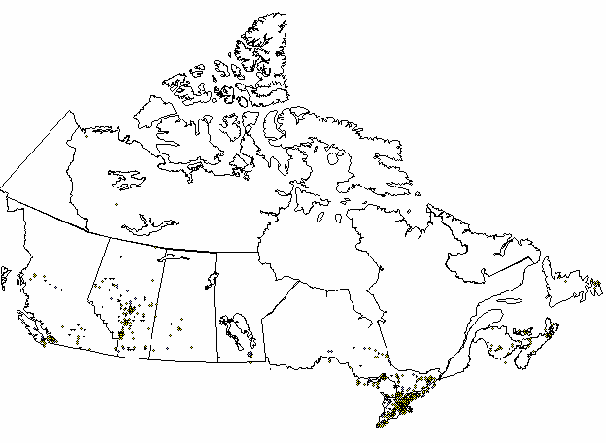

This map shows both Katz corporate and independent store locations in Canada. Currently, there are no stores in the province of Quebec.

Head Office Locations

Katz Group Canada Ltd.
5965 Coopers Avenue
Mississauga, ON
L6Z 4R9

The Katz Group
#1702 Bell Tower
10104-103rd Avenue
Edmonton, AB
T5J 0H8

Drug Trading Company Ltd.
131 McNabb Street
Markham ON
L3R 5V7

Appendix B: Present Application Systems Overview

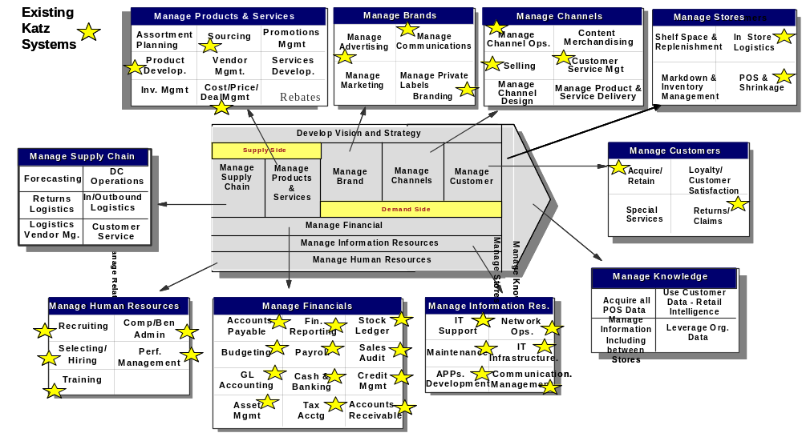

Appendix C: Statement of Confidentiality

Confidentiality
The vendor shall not disclose to anyone, other than the vendor’s employees, officers and advisors directly connected with responding to this RFP who have a need to know information which it contains, or any information concerning this RFP. Vendor shall ensure that such employees, officers and advisors are aware of the confidential nature of such information and that they have agreed to maintain the confidentiality of such information prior to disclosure. No news release, public announcement, or any other reference to this RFP or any phase of any program hereunder shall be made without the prior written consent of Katz Group Canada Limited. Vendor acknowledges and agrees that if, as a result of Vendor’s response to this RFP, additional information is disclosed to vendor by Katz Group Canada Limited or its affiliates, Katz Group Canada Limited may require the execution of a Confidentiality Agreement in form and substance satisfactory to Katz Group Canada Limited acting reasonably.

Proprietary Data
Any and all proprietary data and confidential information contained within this RFP shall be safeguarded with the same degree of protection the vendor exercises with respect to the protection of its own proprietary data and most confidential information.

Reservations
Issuance of this RFP does not commit Katz Group Canada Limited to pay any costs incurred in the preparation and submission of a response, or to procure a contract for any services, software, or equipment.

Reliance on Responses
Vendor acknowledges that Katz Group Canada Limited will be relying on responses submitted by vendor pursuant to this RFP and that such responses are material to any negotiations which may result from this RFP or any contract which may be awarded pursuant to this RFP. Vendor covenants that all such responses will be complete and accurate in all material respects.

Acknowledgment of Confidentiality
(To be returned upon receipt of the attached document)

Name of vendor : ________________________________________

Signed by : _____________________________________________

Title: _____________________________ Date: ____

Appendix D: Key Business Capabilities & Probable Business Releases

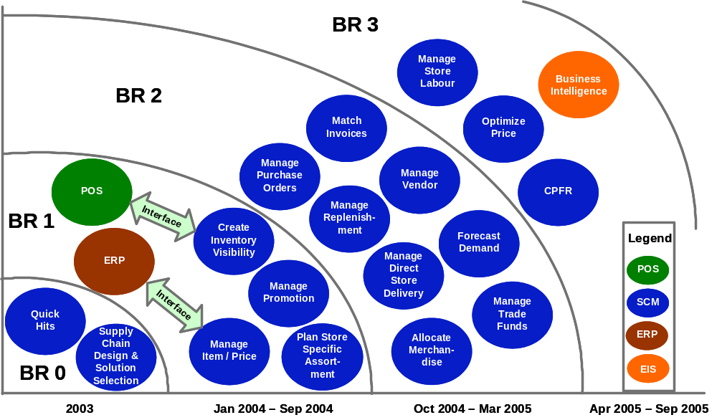

Appendix D: To-Be Process Maps Based on Leading Practices

Strategic Planning & Analysis Process Map

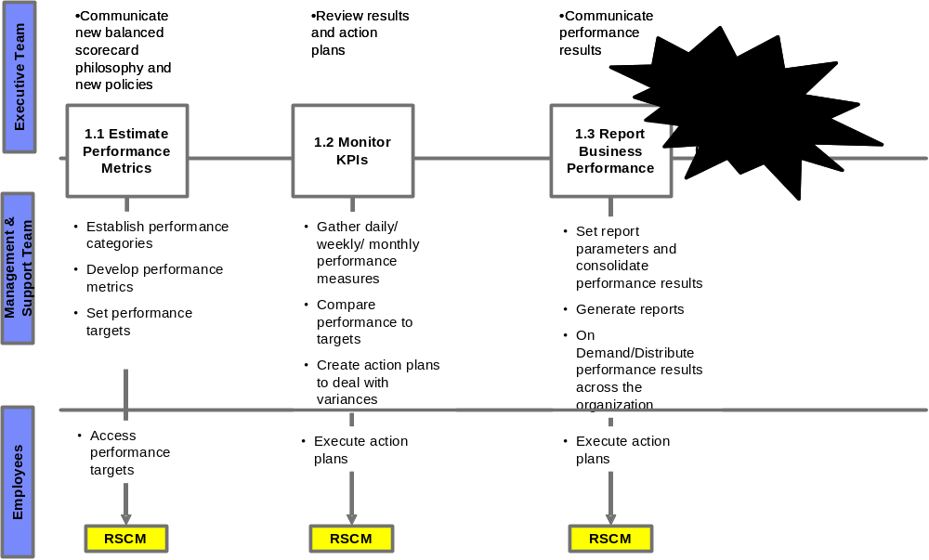

Merchandise Planning Process Map
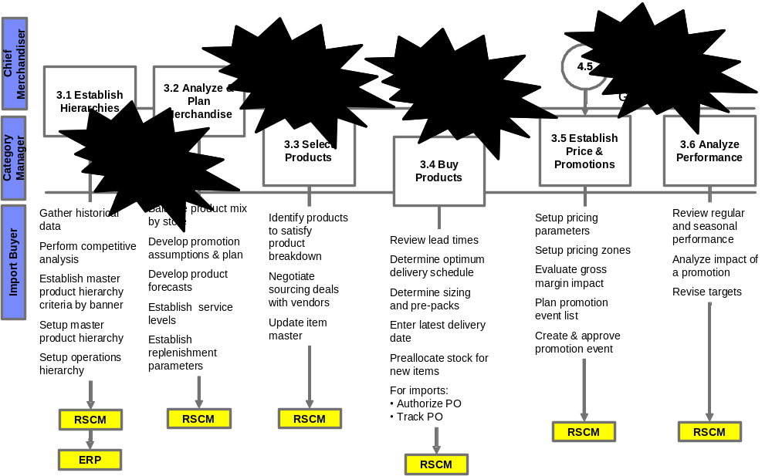
Planning & Distribution Process Map
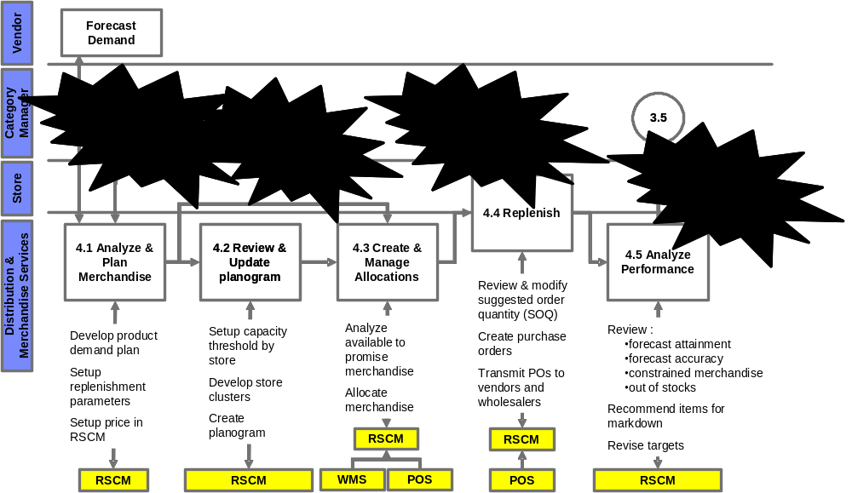
Manage Suppliers Process Map

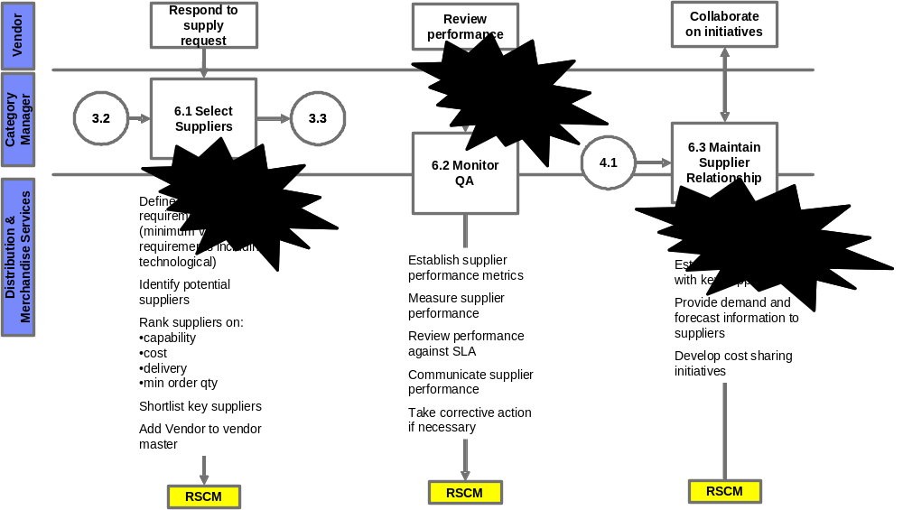
Manage Store Operations Process Map
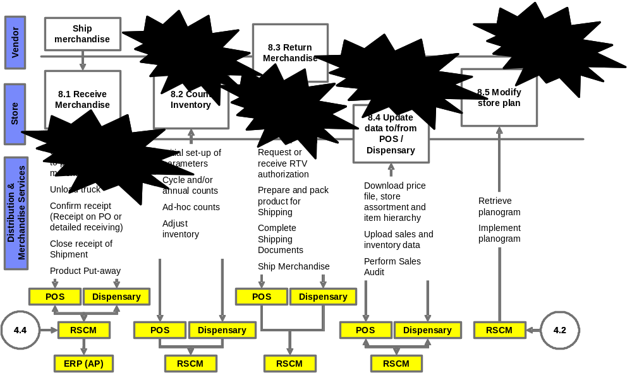

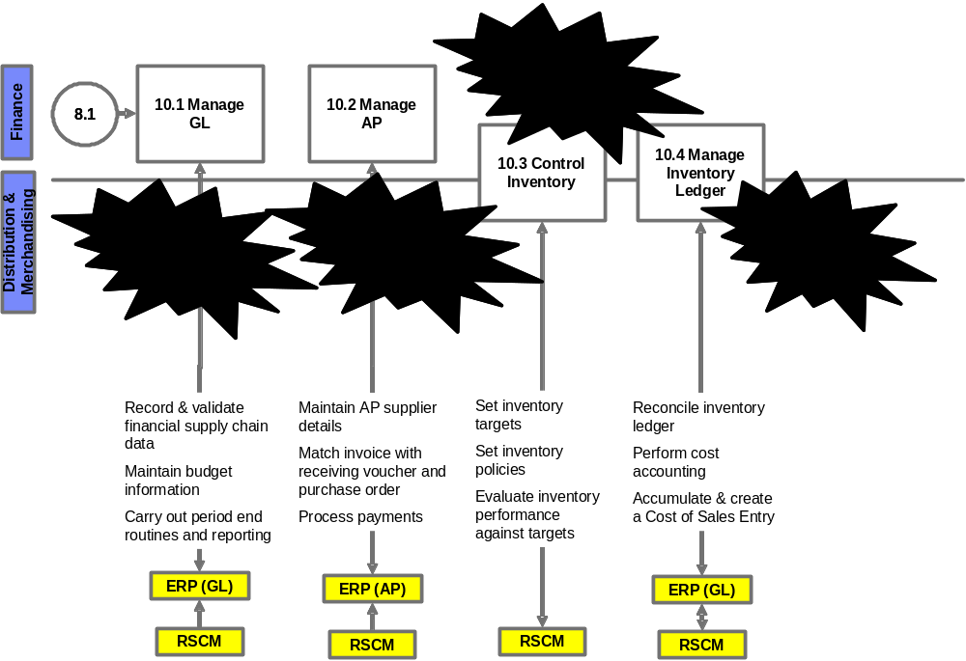
Supply Chain Finance Process Map

